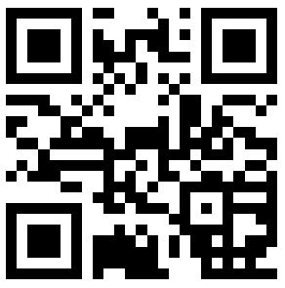

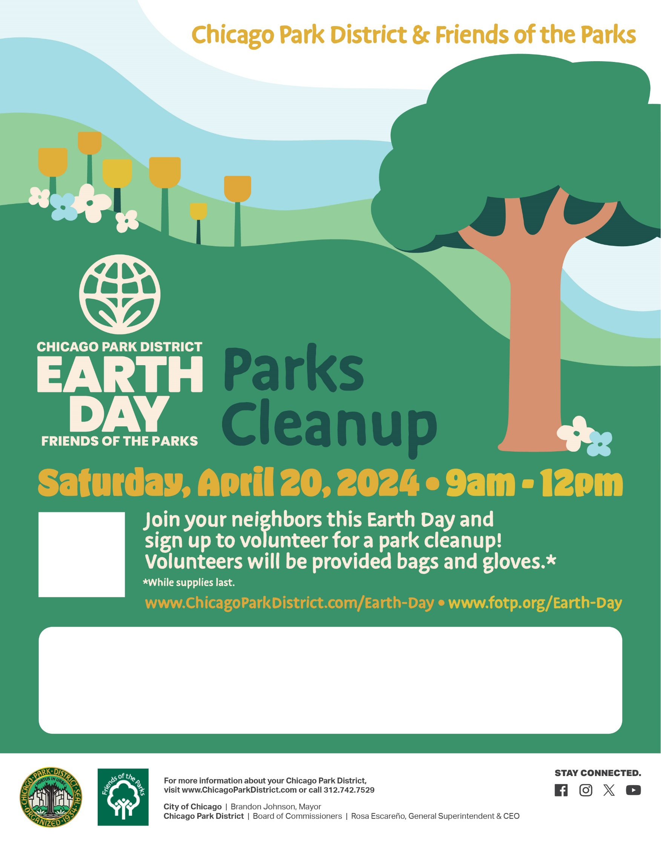

See below for your park’s  
time window.



Customize flyer with park name, contact info, event time, meet up spot, registration link, and other event details. You can also create a QR code for your registration link and use it instead if the general Earth Day website QR code above.